Maths test

This test will consist 50 questions and 45 mins to finish

No calculators are allowed along with electric gadgets

Do not open this paper until you are told so

Please fill the information provided and needed

### Preparation for:

11+ exam

### 

**Pow papers present 11 plus exam papers and mocks. For specific papers of private/grammar school,head over to powpapers.co.uk.**

| Best sellers |  |
| --- | --- |
| **Pow papers** presents |  |

# 1. What is 209876 + 87654

# 2. 987-799

(for a different method head over to last few pages)

# 3. 789 times 654

# 

# 4. 3456 divided by 7

# 5. Bob is doing this question and is struggling. Show him how to do it and the answer.

89-45(4 times 3)+62=?

**Pow tip: bidmas**

# 6. There are 850 children in Charlie's school, the ratio of boys to girls is 3:2. What is the product of the boys and girls in Charlie's school?

# 7. The mean of x numbers is y. What is the sum of the numbers,if

x=24x+5=10+4x

y= mode of 9 8 7 6 5 4 3 3 2 1 3 1 09 8 7 6 54 65 76 54 76 54 87 09 32 75 74 65 32 45 32 45 32 46 32 49 32 40 32 32 32 32 32 90 89 32 32

# 8. What is the mediun of 76 3 5 6 78 35 46 87 65

### 

**9.what is the range of the largest 6 digit number and smallest 3 digit number.**

**10. Ben goes to the shop and sees a t shirt he likes, it costs 5 times his age, but he sees the same t shirt on amazon for 40 percent of the shop price.**

**If ben was born in 2007, and the date this year was 2095, what is the sum of the amazon price and shop price.**

**11. What does average mean, with an e.g.**

**12. This is a pie chart showing what transport people 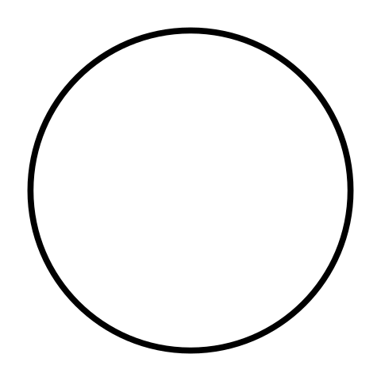use in otsoin primary school.**

**Car:26%**

**bus:34%**

**walk:15%**

**cycle:45%**

**If there are 980 people in otsoin primary school, list the number of people who travelled in separate transportations.**

**13. Questions 13-15 will be based on this venn 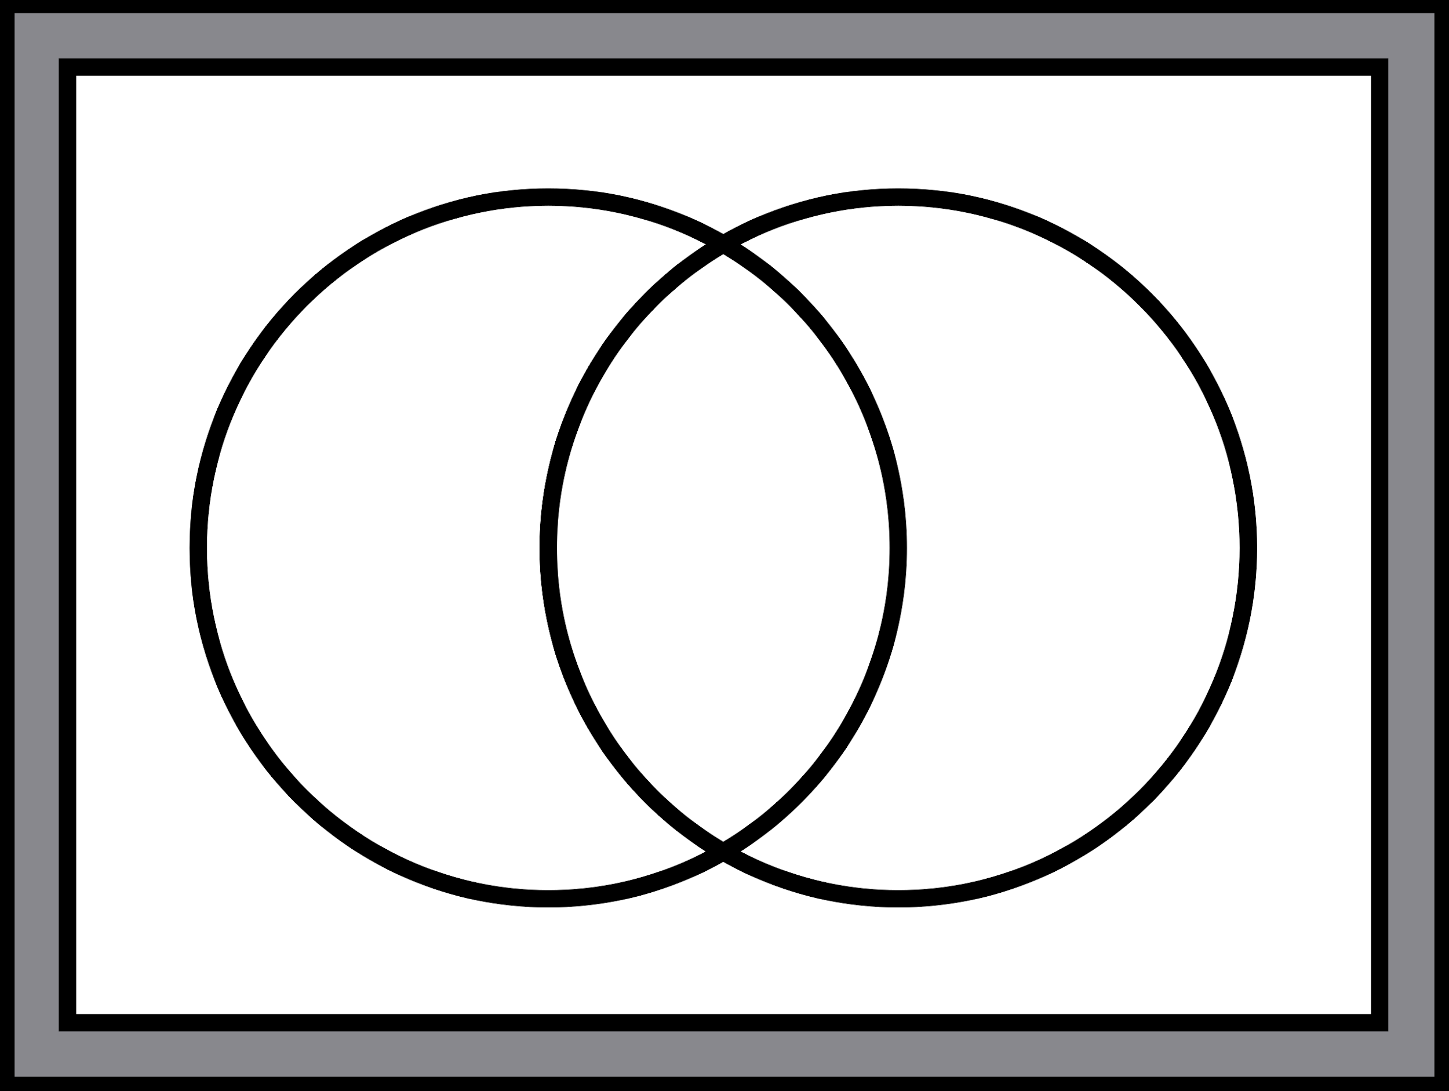diagram.**



**Football:400**

**Rugby:200**

**both:5**

**nothing:55**

**Roger asked his classmates, which sport they liked out of football and rugby. If there are 650 children in ointoin school ,**

**13.How many people likes both football and rugby.**

**14.What is the mediun of people who like the sports above.**

**15. What is the sum of the numbers+the range of numbers+the mediun+the average**

**16. Questions 16-20 will be based on angles**

**17.What is the outer angle if the inner angle is 234 degrees?**

**18.What is the outer angle of a vertex of a square**

**19.what is 4.5/30 of the ¼ of the degrees in a circle**

**20. Draw an accurate scalene triangle, labelling the angles.**

**21.If a square measures 60 by 60 how many tiles measuring 15 by 15 can fit into this square floor.**

**22.Bob is playing monopoly, he roles the dices (2) hoping to roll a sum of a prime number.**

**23. What of the following is the range of fractions/decimals**

**3/7 2/7 5/9 8/12 0.894 7/100**

**24.Questions 24-30 will consist questions of shapes.How many lines of symmetry does a decagon have.**

**25. What do you call a 5 sided shape**

**26.what is the order of rotational symmetry in a regular heptagon**

**27. What is the order of rotational symmetry in a circle.**

**28. If a square includes 16 squares and shaded in a t shape (4 down 4 across), what is the maximum amount of squares needed to be shaded to have x line of symmetry.**

**x= the average of 10 12 18 1 2 3 4 5 1 2 1 1 5 1 1 1 2 3 2 1 1 2 3 7 11**

**29. What is the size of one angle in a octagon**

**30. What do you call an 9 sided shape**

**31.what is ¼ of the volume of a cube if ,**

**l= (27% of 6500 + 6500% of 25)-2**

**32. Questions 32-40 will be based on number sequences . write the next number in the sequence ,next to the question mark.**

**33.98,49,50,25,?**

**34.5,6,8,11,15,?**

**35.8,9,13,22,38,?**

**36.2,4,6,10,16,26?**

**37.8,783,16,87,32,65,?**

**38.0,1,1,2,3,5,8,?**

**39.988,494,246,?**

**40. 1,8,15,22?**

**41.I roll 3 fair dice, what is the probability that the first dice will show a prime number, the second one will show a square number and the third dice will show a triangular number.write your answer in the lowest form.**

**42.I bounce a bouncy ball, every bounce it takes it decreases 1.54cm, if the first bounce is 4.65metres, how tall will the last bounce approximately be.**

**43.I drew a rectangle, the length(l) is 1/x of the width(w) if x is the 6th triangular number and the w is 237-2x=1x-300. What is the perimeter of the rectangle?**

**44.Ben is measuring the area of the rectangle,if the length is half the width what is the area.**

**width =76589.33**

**45.what is the perimeter if of a square if the area is 625cm2**

**46. Questions 46-49 will be based on ‘nth term sequence’Look at the sequence below.**

**… ……. ……….. ……………**

**How many dots will there be in the 1098th sequence.**

**47. / //// ///////// //////////////// ////////////////////////**

**How many lines will there be in the 209th sequence**

**48. o ooo oooooo oooooooooo**

**How many o’s will there be in the 10th sequence**

**49. U uuuuuuuu uuuuuuuuuuuuuuuuuuuuuuuuuuu**

**How many u’s will there be in the 11th sequence**

**50. A car travels 120km in 3hours, what is the average speed in metres.**

**notes:**

**Time , distance, speed (tds)**

To answer a tds problem follow these rules,

You’ll be given a set of information, e.g lets say a car is travelling 6 meter in 2mins what is the speed. You do d/t which is 3m/h.